**CSCI 5709 – ADVANCED WEB SERVICES**

**Assignment 1**

**Instructor:** Gabriella Mosquera

Group - 07

|  |  |
| --- | --- |
| **Name** | **Banner ID** |
| Harshil Shah | B00919966 |
| Raj Soni | B00918159 |
| Aanandi Ramnikbhai Pankhania | B00930007 |
| Yatrik Pravinbhai Amrutiya | B00943349 |
| Viral Siddhapura | B00913032 |

**‘ClassMate’: School at your fingertips!**

# A1.1 (Project’s Purpose, Goals, and Intended Features)

## Purpose:

The classmate application provides a digital platform for students, professors, and campus administrators to efficiently manage and interact within an educational setting. It aims to streamline administrative tasks, facilitate effective communication between students and professors, and enhance the overall learning experience.

## Goals:

Our goal revolves around simplifying administrative processes, fostering effective communication between students and professors, and promoting a collaborative learning environment. We aim to provide Efficient Administration Management that enables professors, course, and student provisions to create an associative environment. Professor Dashboard provides assignment and quiz module administration. Using Student Dashboard, students can get notifications of upcoming deadlines for all enrolled courses in one place, for specific courses students can access assignments and quizzes and get grade updates. The Course Discussions tab provides a comprehensive discussion portal for students and professors for doubt resolution or other queries. A comprehensive newsletter that provides current news from admin university wide.

## Intended Features:

1. User Management:

Unified page for Professor Student registration (Accessible only to admins), login or deleting a specific account (Accessible only to admins). It also provides an option to reset a password through forgot password option.

**Tasks:**

* **Student and Professor registration:** Setting up the process for new student or professor to create an account and provide basic information such as first name, last name, email, and password.
* **User authentication:** Verifying the identity of users through login credentials using email and password and forgot password functionality.
* **User profile management:** Allowing users to view and update their information.
* **User account Deletion:** Once user becomes inactive only admins have authority to delete the account.

1. Student & Professor Dashboard

It provides students with a user-friendly interface to access their enrolled courses. Students will be able to submit assignments, take quizzes, and receive notifications for valuable information such as due dates and announcements. They should also be able to read course-specific announcements. Student will be able to update their profile.

**Tasks:**

**Analytics dashboard:**

* + - * **View Student Performance:** The analytics dashboard allows professors to access detailed information about student performance, such as individual grades, assignment scores, and test results. They can gain insights into how students are progressing and identify areas where additional support may be needed.
      * **Identify Passing and Failing Students:** Professors can use the analytics dashboard to identify students who are meeting or exceeding expectations (passing) as well as those who may be struggling (failing). This information helps professors intervene and provide appropriate guidance or resources to help students succeed.
      * **Track Enrollment Data:** The analytics dashboard provides data on enrolled students, allowing professors to monitor class size, enrollment trends, and student demographics. This information helps in understanding the composition of the class and making informed decisions about instructional strategies.
      * **Analyze Assessment Results:** Professors can analyze assessment results through the analytics dashboard to gain insights into how students are performing on specific assignments, tests, or quizzes. They can identify areas of strength and weakness in student understanding and adjust their teaching accordingly.

**List courses:**

* **For Student:** The "List Courses" feature allows students to conveniently access and view their enrolled courses in a well-organized manner. It provides a snapshot of essential course information, such as course names, instructors, and schedules, enabling students to easily navigate and engage with their academic content.
* **For Professor:** The "List Courses" feature provides professors with a clear and organized view of their courses, including key details like course names, enrollments, and schedules, streamlining course management and navigation.

**MANAGE content:**

* **Share content:** The "Share Content" feature simplifies the process of distributing educational materials, allowing professors to manage and share course resources effortlessly. It promotes collaboration and enables students to access relevant materials for an enhanced learning experience.

**View content:**

* **Access materials:** The "View Content" feature enables students to conveniently access and explore course materials shared by their professors. It provides a user-friendly interface for browsing and engaging with educational resources, fostering a seamless learning experience.

**Announcement:**

* **For professor:** The "Announcement" feature enables professors to easily communicate important news and updates to their students, ensuring efficient information dissemination and keeping students informed.
* **For students:** The "Announcement" feature allows students to stay updated with important course information, such as deadlines, schedule changes, and general announcements, fostering effective communication between professors and students.

**Profile updates:**

* **For professor:** The "Profile Update" feature enables professors to keep their professional information up to date, including personal details, qualifications, and contact information, ensuring accurate and current representation.
* **For students:** The "Profile Update" feature allows students to maintain their personal information, update contact details, and provide relevant details such as interests or areas of study, ensuring accurate and comprehensive profiles within the educational platform.

1. Admin Dashboard:

The admin dashboard is designed to provide administrative control over the course management system. It allows the administrator to perform MANAGE (Create, Read, Update, Delete) operations for courses, approve professors, and map professors to their respective courses.

**Tasks:**

**Course Management:**

* **Create Course:** The admin can create new courses by providing details such as course name, description, start date, and end date.
* **Read Course:** The admin can view the list of existing courses, including their details and associated professors.
* **Update Course:** If there are any changes to a course's information, the admin can update the course details, such as its name, description, or dates.
* **Delete Course:** In case a course is no longer needed or has been discontinued, the admin can delete it from the system.

**Professor Approval:**

* **Approve Professors:** When professors register in the system, their applications are sent for approval. The admin can review and approve professors based on their qualifications and credentials.
* **Read Professor Details:** The admin can view a list of professors awaiting approval, along with their personal information and qualifications.

**Professor-Course Mapping:**

* **Map Professors to Courses:** Once the professors are approved, the admin can assign them to specific courses. This mapping ensures that each course has the appropriate professor responsible for it.
* **Read Mapping Details:** The admin can access the list of courses and their assigned professors to keep track of the allocation.

### Assignment Management:

As our Brightspace or any online education platform suggests, professors can upload assignments and students can view those assignments and upload before the due deadline. The details of assignments feature are as follows:

**Tasks:**

**Professor Side Assignment View:**

* **Create & Upload Assignment:** Professor can create the assignment and upload it through file upload systems using either .pdf or .doc file. We will have a separate page for uploading files for an assignment.
* **Update Assignment:** Professor can also update the assignment as they feel it needs to be changed in future and set the deadline accordingly.
* **Assignment Constraints:** Professor is required to set some constraints regarding an assignment like Due date, visible date, description of assignment, assignment weightage and an attachment to that.
* **Visible Date:** Professor can set a visible date for an assignment to the students stating that this assignment should be visible to the students on a particular date or time otherwise not visible to them.

**Student Side Assignment View:**

* + **View Assignments:** On student dashboard, at the assignment tab, students can see their courses assignments listed with the basic details.
  + **Assignment constraints:** Students can see their assignments listed with detailed information like description, deadline, status of assignment (Either completed or in complete) and assignment names and its attachment.
  + **Submission:** Students can upload the submission file using file upload window systems, where they can upload either .pdf or .doc file along with some important description (let say some important links to the attachment). Once they submit the assignment, they can look into grades section for scores feedback.

1. Quiz Management:

To check the knowledge Professor set quiz which can be managed and updated. Students can view the quiz and submit their answers, to secure a good score. Below is the detail of this feature, distributed among professor and student:

**Tasks:**

**Professor Side Quiz View:**

* **Create Quiz:** By specifying the questions, response options, and any additional instructions or constraints, professors can construct quizzes.
* **Question Bank:** Professors can manage a question bank, by adding question through forms or uploading a csv file for multiple questions. This allows them to store and organize a pool of questions for reuse in multiple quizzes or assessments.

**Random Questions:** Professors can choose to randomize the order of questions for each student. This prevents cheating during quizzes, as students will receive different question sequences.

* **Quiz Time:** Professors set the time for specific quizzes. This ensures that students have a specific duration within which they need to answer the questions. It allows professors to control the pace of the quiz and ensures fairness among students.
* **Visible Date:** Professor can set a visible date for a quiz to the students stating that this quiz should be visible to the students on a particular date or time otherwise not visible to them.

**Student Side Quiz View:**

* **View Quiz:** On student dashboard, at the quiz tab, students can see their courses quizzes listed with the basic details.
* **Specific Quiz:** On a single quiz page, students can see the questions and options for each question.
* **Quiz Submit:** After successfully completing the quiz students can submit it and check their marks in the grade section.
* **Quiz review:** Students can learn from their mistakes by reviewing the correct answers. So, after completing the quiz, students can review their quiz results, i.e., correct and incorrect answers provided by the professor.

1. Grades Management:

Grade's function is made to manage and keep track of students' performance on various assessments, such as quizzes, projects, assignments, and exams. Grades can be viewed and configured per course. The following are the tasks and intended features for the grades feature:

**Tasks:**

**Professor Side Grades View:**

* **Weightage:** Professor can configure the weightage of different assessments such as assignment, quiz and exams. This allows for the calculation of weighted averages and helps determine final course grades accurately. This can be used to calculate the final grade of the course.
* **Grade Entry:** Professors enter grades for various assessments (quizzes, assignments, exams). They assign numerical scores, letter grades, or use a grading scale determined by the institution.
* **Grade Visibility:** Professor can set when to make the grades such as allowing students to see individual assignment grades, overall course grades, or both.
* **Grade comments/feedback:** Professor provides the feedback or comments for the assignments either via text or files. This will help students to understand their strengths and areas for improvement.

**Student Side Grades View:**

* **View Grades:** Student can view their individual grades summaries for all the assessments.
* **View Feedback:** Students can see the remarks and feedback provided by the professor for their tests or assignments. They can learn from this input about their strengths and weaknesses and adjust for upcoming assignments.

### Notifications Management

The Notification Management feature ensures effective communication and timely updates between professors and students within the course management system. It includes various types of notifications that inform students about assignment and quiz visibility, approaching due dates, grades/feedback, and newly created course content. Additionally, students can view their notification history.

**Tasks:**

* **Assignment and Quiz Visibility:** Whenever a professor opens a quiz or makes an assignment visible, notifications are automatically sent to all students enrolled in the course.
* **Due Date Approaching:** Students receive a notification one day before an assignment's due date is approaching.
* **Grades/Feedback:** Whenever a quiz grade is updated or when a professor provides grades and feedback for an assignment, students receive a notification.
* **Content Created:** Whenever a professor uploads new content specific to a particular course, such as lecture notes, slides, or additional resources, students receive a notification.
* **View Notifications:** Students have access to a dedicated notification center where they can view all their notifications in one place.

### University Newsletter Management:

The Newsletter Management feature provides administrators with the ability to create, manage, and distribute newsletters within the course management system. Administrators can perform MANAGE (Create, Read, Update, Delete) operations for newsletters, while professors and students have read-only access to view the newsletters.

**Tasks:**

1. **Create Newsletter:** Admins can easily create newsletters. They have the flexibility to customize the newsletter according to the specific needs and objectives.
2. **Read Newsletter:** Admins, professors and students can access the newsletters within their respective dashboards. They can view all the content shared by the administrators.
3. **Update Newsletter:** In case there are any changes required for a newsletter, admins can make necessary modifications to the content. This ensures that the information remains accurate and up-to-date.

* **Delete Newsletter:** If a newsletter becomes obsolete or is no longer relevant, administrators can delete it from the system. This helps to maintain a streamlined collection of newsletters and avoids confusion or outdated information.

### Discussion Management

Professors can have multiple discussions possible per course so that they can communicate with the students easily.

**Tasks:**

* **Create Discussion:** Professor will create a chat option once a professor will require to pass some important news / announcements with students:
* **Read Discussion:** Students on the other side will get the notification and they can open that chat once they go to Discussion tab at Student Dashboard. They can join the chat option.
* **Update Discussion:** Professors and students can update their responses whenever they feel like they need to change it. It will be reflected on both the chat side (Professor side as well as student side).
* **Delete Discussion:** Professors can **Only** delete the chat option as they feel they do not require to be communicate further. Once deleted it will be removed from both the dashboard (professor and student).

.

1. Calendar Management

Shows deadline across all courses, both to the professor as well as student to get an overview of all the due dates at one place.

**Tasks:**

* **Course Integration:** Calendar view of upcoming deadlines across all the courses.
* **Easy traversal:** Student and professor can easily go to any course’s deadline and perform actions.
* **Division:** Divided between past deadlines & upcoming deadlines for quick overview.

# A1.2 User Personas and Intended Scenarios

## User Personas

### Admin

Figure 1: User persona for Admin.

### Student

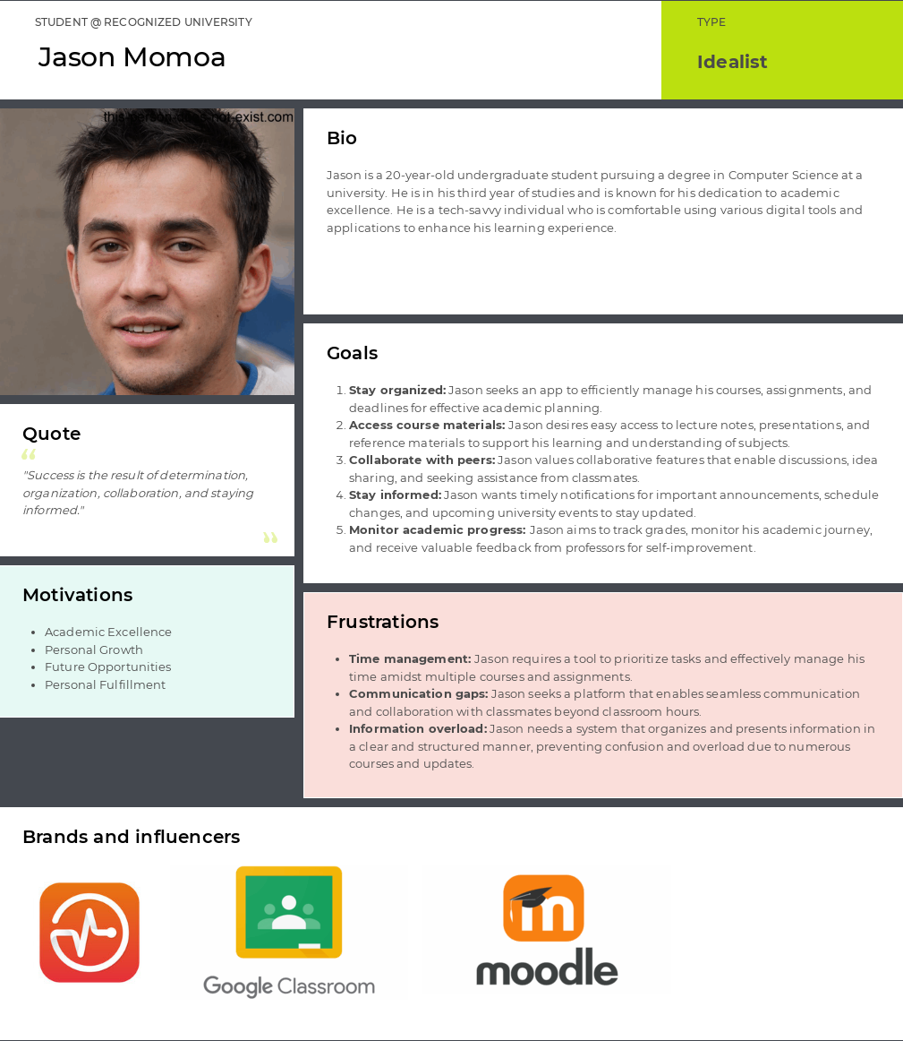

Figure 2: User Persona for student.

1. Professor

Figure 3: User persona for professor.

## Intended Scenarios

1. Student and professor dashboard

#### Create content

The Professor– Dr. Greg Blesser effortlessly creates and shares lecture notes, slides, readings, and videos with his students using the "Share Content" feature. This promotes collaboration, engagement, and easy access to relevant course materials, enhancing the overall learning experience.

Table 1: Share content Intended scenario

|  |  |
| --- | --- |
| Persona | Professor (Dr. Greg Blesser) |
| Feature | Create content (professor) |
| Need | The "CreateContent" feature addresses the need for seamless distribution of educational materials, ensuring easy access to resources for students and facilitating effective teaching practices for professors. |
| Context | Professor wanted to share relevant content with their students |

#### View content

Professor Dr. Greg Blesser utilizes the "View Content" feature to access and review shared course materials. This allows him to conveniently view lecture notes, readings, and other resources uploaded by himself or other professors, enabling him to stay informed and prepared for class discussions and lectures. The "Read Content" feature facilitates efficient content consumption and supports effective teaching practices.

Table 2: View Content Intended Scenario

|  |  |
| --- | --- |
| Persona | Professor (Dr. Greg Blesser) |
| Feature | Create content (professor) |
| Need | The "Read Content" feature addresses the need for convenient access to course materials, enabling professors to review shared resources for effective teaching and preparation. |
| Context | Professor wanted to view content shared with their students |

#### Delete Content

Professor Dr. Greg Blesser utilizes the "Delete Content" feature to remove outdated or irrelevant course materials from the platform. This ensures that students have access to the most up-to-date and accurate resources, maintaining the integrity and relevance of the course content. The "Delete Content" feature allows for efficient content management, streamlining the learning process for students.

Table 3: Delete Content Intended Scenario

|  |  |
| --- | --- |
| Persona | Professor (Dr. Greg Blesser) |
| Feature | Create content (professor) |
| Need | The "Delete Content" feature addresses the need for efficient content management, allowing professors to remove outdated or irrelevant materials and maintain the relevance of course content for students. |
| Context | Professor wanted to delete some outdated content shared with their students |

#### Update Context

Professor Dr. Greg Blesser utilizes the "Update Content" feature to make necessary revisions or additions to course materials. This ensures that students have access to the most accurate and up-to-date resources, providing them with the latest information and enhancing their learning experience. The "Update Content" feature enables seamless content maintenance and promotes continuous improvement in course delivery.

Table 4: Update content Intended Scenario

|  |  |
| --- | --- |
| Persona | Professor (Dr. Greg Blesser) |
| Feature | Update content (professor) |
| Need | The "Update Content" feature addresses the need for keeping course materials current and relevant, allowing professors to make revisions or additions to resources for an enhanced learning experience. |
| Context | The professor wanted to update some content shared with their students as they made some mistakes. |

#### Analytics dashboard

Professor Dr. Greg Blesser utilizes the "Analytics Dashboard" sub-feature to view student performance metrics, including grades, attendance, and participation in various courses. This allows him to assess student progress, identify areas for additional support, and make informed decisions regarding teaching strategies and interventions.

Table 5: Update content Intended Scenario

|  |  |
| --- | --- |
| Persona | Professor (Dr. Greg Blesser) |
| Feature | Update content (professor) |
| Need | The Analytics Dashboard sub-feature addresses the need for professors like Dr. Greg Blesser to access and monitor student performance metrics, facilitating data-driven insights and informed decision-making for effective teaching and support. |
| Context | The professor shall use analytics dashboard to get deeper insights into |

#### List courses

Student Jason Momoa utilizes the "List Courses" sub-feature to browse and explore available courses. This allows him to view course descriptions, prerequisites, and other relevant details, helping him make informed decisions regarding course enrollment and academic planning.

Table 6: Update content Intended Scenario

|  |  |
| --- | --- |
| Persona | Student (Jason Momoa) |
| Feature | Update content (professor) |
| Need | The List Courses sub-feature addresses the need for students like Jason Momoa to explore and access comprehensive course listings, facilitating informed decision-making and effective academic planning. |
| Context | Jason will use list courses features to access his current courses. |

#### View content (Student)

Student Jason Momoa utilizes the "View Content" sub-feature to access and review course materials, such as lecture slides, readings, and multimedia resources. This allows him to engage with the content outside of the classroom, reinforce his understanding, and prepare for upcoming assignments and assessments.

Table 7: Update content Intended Scenario

|  |  |
| --- | --- |
| Persona | Student (Jason Momoa) |
| Feature | Update content (professor) |
| Need | The View Content sub-feature addresses the need for students like Jason Momoa to easily access and review course materials, supporting self-paced learning and academic preparation. |
| Context | Jason will view content shared by professor in the system. |

#### Announcement

Student Jason Momoa receives notifications through the "Announcements" sub-feature regarding important updates, news, and announcements from professors and the institution. This ensures that he remains informed about any course-related changes, upcoming events, and academic opportunities.

Table 8: Update content Intended Scenario

|  |  |
| --- | --- |
| Persona | Student (Jason Momoa) |
| Feature | Update content (professor) |
| Need | The Announcements sub-feature addresses the need for students like Jason Momoa to receive timely notifications about important updates and news, facilitating effective communication and engagement within the academic community. |
| Context | Jason will view announcements shared by the professor. |

#### Profile updates

Student Jason Momoa utilizes the "Profile Updates" sub-feature to manage his personal information, such as contact details, preferences, and academic interests. This allows him to maintain an up-to-date profile and ensure accurate communication and engagement within the learning platform.

Table 9: Update content Intended Scenario

|  |  |
| --- | --- |
| Persona | Student (Jason Momoa) |
| Feature | Update content (professor) |
| Need | The Profile Updates sub-feature addresses the need for students like Jason Momoa to manage and maintain their personal information, facilitating accurate communication and personalized academic experiences. |
| Context | Jason will use the profile update feature to make some changes to their profile. |

1. University Newsletter

#### Post News

The admin – Jacques wants to notify the whole university about a specific event happening in the main ground a few days before. Via this feature, he can do announcements like this to the whole university (all students and professors). Admin can also use this feature as day-to-day news about what is going on within campus and if there are any specific problems happening around any area.

Table 10: Post News Intended Scenario

|  |  |
| --- | --- |
| Persona | Admin (Anya Thompson) |
| Feature | University Newsletter |
| Need | To inform the entire university community about important events, announcements, and updates, as well as address any campus-related issues. |
| Context | Student wanted to take an upcoming quiz before deadline passes |

#### Edit News

While performing the above step, Jacques made a mistake, and he wants to modify some of the content.

Table 11: Edit News Intended Scenario

|  |  |
| --- | --- |
| Persona | Admin (Anya Thompson) |
| Feature | University Newsletter |
| Need | To edit and modify news in the newsletter |
| Context | The admin made the mistake in date/year of a specific event. The location of the event got changed at the last moment. |

#### Delete News

Admin posted a rumor which he thought was true but turned out to be wrong. So, now he wants to remove the news.

Table 12: Delete News Intended Scenario

|  |  |
| --- | --- |
| Persona | Admin (Anya Thompson) |
| Feature | University Newsletter |
| Need | To delete an unwanted news |
| Context | Admin wants to delete the news as he does not want people to see that now |

#### View Post

Professor and student want to check out all the news published by Admin’s to see what is happening around the campus (e.g., to find interesting activities or which roads to avoid while on campus).

Table 13: Delete News Intended Scenario

|  |  |
| --- | --- |
| Persona | Student (Jason Momoa), Professor (Greg Blesser) |
| Feature | University Newsletter |
| Need | To view all news published by the admin at one place in the dashboard |
| Context | Student and Professor’s wants to check latest news around campus (e.g., mask policy, exam dates, etc.) |

1. User Management:
   1. User Registration

In a classroom environment, Anya, Jason, or Greg want to register onto ClassMate website. They want to register themselves by giving more information about them on the website such that they identify their roles and see the features.

Table 14: User Registration

|  |  |
| --- | --- |
| Persona | Admin (Admin Anya), Student (Jason Momoa), Professor (Greg Blesser) |
| Feature | User Management |
| Need | To register a user with some information on the website. |
| Context | The user decided to sign up as a new user because they wanted to access more features. |

3.2 User Login

Anya, Jason, or Greg have already registered themselves as their intended role and created their account into database. Now they want to access the features of the website.

Table 15: User Login

|  |  |
| --- | --- |
| Persona | Admin (Admin Anya), Student (Jason Momoa), Professor (Greg Blesser) |
| Feature | User Management |
| Need | To login a user with some information on the website. |
| Context | User was logged out despite having an account already. They must check in to access all the features. |

3.3 Forgot Password

Anya, Jason, or Greg already registered on the website and successfully created their intended account. Now, they want to login into their account, but it doesn’t work as it is saying incorrectly. So, they want to reset their password.

Table 16: Forgot Password

|  |  |
| --- | --- |
| Persona | Admin (Admin Anya), Student (Jason Momoa), Professor (Greg Blesser) |
| Feature | User Management |
| Need | To offer users the ability to reset their passwords if they forget theirs |
| Context | User wants to generate a new password after forgetting their current one. |

3.4 View User Profile

Anya, Jason, or Greg already registered on the website and successfully logged onto their intended account. Now, they want to see their profile how it looks like.

Table 17 User Profile Persona

|  |  |
| --- | --- |
| Persona | Admin (Admin Anya), Student (Jason Momoa), Professor (Greg Blesser) |
| Feature | User Management |
| Need | To see personal basic details accordingly |
| Context | Users can see their profile |

3.5 Delete Accounts

Anya has found some bad professors or students who have been created somehow and she wants to delete them from the website, so she wants to revoke their accesses.

Table 18 Delete accounts Persona

|  |  |
| --- | --- |
| Persona | Admin (Admin Anya) |
| Feature | User Management |
| Need | To delete the account for professors and students from the courses |
| Context | User felt like something bad happened or intentionally done something to students or other colleagues – then Admin will remove such bad users. |

1. **Assignment Management:**  
   1. Assignment Creation:

Professor Greg wants to give some assignments to the students in a particular course. So, the professor will upload a either .pdf or .doc file into file upload window page and the registered students will get that assignment with basic details:

Table 19 Assignment Creation Table

|  |  |
| --- | --- |
| Persona | Professor (Greg Blesser) |
| Feature | User Management |
| Need | To create the assignment and assign it to the students. |
| Context | The professor can give some tasks to their students so that they can grade them. |

4.2 Assignment View:

A student Jason wants to view the given assignment with the details like an attachment, description, and the final submission deadline.

Table 20 View Particular Assignment

|  |  |
| --- | --- |
| Persona | Student (Jason Momoa) |
| Feature | User Management |
| Need | Instructions to be followed as per description and progress purpose. |
| Context | A student can see the assignment which was created by professor and he or she is intended to do that within the given timeline. |

4.3 Visible Date

Professor Greg wants to set up a page where once assignments are created, students can only be able to see the attachment on a particular date otherwise till date students can see only viewable assignment list.

Table 21 Visible Assignment Date

|  |  |
| --- | --- |
| Persona | Student (Jason Momoa) |
| Feature | User Management |
| Need | To manage proper submission deadline and progress window of students over a period. |
| Context | Jason will see that once the visible date is enabled – that assignment will be published on that date only. |

4.3 Submission and Status

Student Jason Momoa wants to submit an assignment. He wants to submit a file using the submission window.

Table 22 Status and Submission of Assignments

|  |  |
| --- | --- |
| Persona | Student (Jason Momoa) |
| Feature | User Management |
| Need | To submit an assignment within a proper deadline. |
| Context | To upload a file, Jason will simply put .pdf or .doc file and once you click on submit, the status of the submission will be reflected as **Completed.** |

1. Quiz Management:
   1. Create Quiz

Professor Greg, utilizing the quiz feature in ClassMate, creates a quiz for the students in a specific course. He customizes the quiz by setting time limits, randomizing question order, allowing multiple attempts, and specifying feedback options. The quiz serves as a formative assessment to evaluate student understanding, provide feedback, and track progress. The facilitates the distribution of the quiz to registered students and provides a platform for them to complete and submit their quiz responses.

|  |  |
| --- | --- |
| Persona | Professor (Greg Blesser) |
| Feature | Quiz Management |
| Need | To create a quiz and assign it to students |
| Context | Professors use quizzes to evaluate student comprehension, provide feedback, and track progress. |

* 1. Question Bank

Using the Question Bank feature, Professor Greg creates a repository of questions categorized by topic or difficulty level. When making quiz, he may quickly access these questions, ensuring a well-rounded and organized evaluation.

|  |  |
| --- | --- |
| Persona | Professor (Greg Blesser) |
| Feature | Quiz Management |
| Need | Centralized repository for managing and reusing questions |
| Context | Professors utilize the question bank feature to efficiently create customized assessments and maintain consistency in evaluations. |

1. Calendar
   1. Course Integration

Jason wants to see what the coming deadline is and for which course. If there is something pressing, he wants to check which course’s deadline is earliest, description of the goal to achieve.

On the other hand, Greg has something urgent came up. He wants to move all the deadlines to another day. He can check all the deadlines on that day and notify student by emailing, posting in discussion channel or announcing it on course channel.

Table 23: Intended Scenario - Student

|  |  |
| --- | --- |
| Persona | Student (Jason Momoa) |
| Feature | Calendar |
| Need | Jason needs the calendar feature to prioritize his tasks by checking upcoming deadlines and associated courses |
| Context | Jason uses the calendar to efficiently manage his academic responsibilities. |

Table 24: Intended Scenario - Calendar - Professor

|  |  |
| --- | --- |
| Persona | Professor (Greg Blesser) |
| Feature | Calendar |
| Need | Greg wants to mark his unavailability to answer student questions on specific days. |
| Context | Greg utilizes it to communicate his availability and ensure students are informed about his unavailability. |

* 1. Easy traversal

Jason wants to gather all the deadlines and traverse to a specific assignment quickly. It also shows a categorized compact view and divide the deadlines between upcoming or past deadlines.

Meanwhile Greg wants to check all deadlines he set for any course.

Table 25: Intended Scenario - traversal - Professor.

|  |  |
| --- | --- |
| Persona | Professor (Greg Blesser) |
| Feature | Calendar |
| Need | The calendar feature to gather and navigate deadlines efficiently |
| Context | Greg forgot to check the holiday before adding the assignments. He wants to send an email notifying all students that has the assignment on that specific deadline. |

Table 26: Intended Scenario - traversal - Student.

|  |  |
| --- | --- |
| Persona | Student (Jason Momoa) |
| Feature | Calendar |
| Need | Jason wants to know the deadlines on a specific date. |
| Context | Jason, as a student, uses the Calendar feature to view and track the deadlines specifically on a particular date. |

1. **Discussion Management:**  
   1. Create Discussion:

Professor Greg wants to create a topic under which he wants to communicate with the students. So, Greg will create a discussion channel for that topic.

Table 27 Create Discussion

|  |  |
| --- | --- |
| Persona | Professor (Greg Blesser) |
| Feature | User Management |
| Need | For communicating important details or requirements regarding classroom. |
| Context | Greg will provide important updates and communicate with students in two ways so that Greg can clear the doubts of the students. |

6.2 View Discussion:

Student Jason Momoa wants to discuss with the professor using the discussion channel which was created by Professor Greg. Now, Jason will send the message to the professor and Greg will respond to the message respectively.

Table 28 View Discussion from Student side

|  |  |
| --- | --- |
| Persona | Student (Jason Momoa) |
| Feature | User Management |
| Need | To share important details – like doubts and insights from assignments, quiz or any topic related to the course. |
| Context | Jason will response to that created discussion topic and describe his views to the professor Greg. |

1. **Notification:**  
   1. Assignment & quiz are visible:

Student Jason Momoa receives notifications when new assignments and quizzes become visible on the platform. This allows him to promptly access and review the assignment details, ensuring he stays informed about upcoming tasks and can effectively plan his study schedule. The Assignment Visibility sub-feature enables Jason to stay organized and prepared for his academic responsibilities.

|  |  |
| --- | --- |
| Persona | Student (Jason Momoa) |
| Feature | Notification |
| Need | The Assignment Visibility sub-feature addresses the need for students like Jason Momoa to receive notifications and access information about newly visible assignments and quizzes, promoting timely awareness and effective task management. |
| Context | Jason will view the notifications about assignment and quizzes. |

8.2 Due dates:

Student Jason Momoa receives notifications about assignment due dates, allowing him to stay organized and submit his work on time. This ensures that he can effectively manage his workload and meet the academic requirements within the given timeframe.

|  |  |
| --- | --- |
| Persona | Student (Jason Momoa) |
| Feature | Notification |
| Need | The Due Dates sub-feature addresses the need for students like Jason Momoa to receive timely notifications about assignment due dates, promoting effective time management and successful task completion. |
| Context | Jason will view notifications about upcoming due dates. |

8.3 Grades and Feedback:

Student Jason Momoa receives notifications about his grades and feedback provided by his professors. This allows him to track his progress, identify areas for improvement, and leverage valuable feedback to enhance his learning and academic performance.

|  |  |
| --- | --- |
| Persona | Student (Jason Momoa) |
| Feature | Notification |
| Need | The Grades & Feedback sub-feature addresses the need for students like Jason Momoa to receive notifications about their grades and feedback, facilitating continuous learning and improvement. |
| Context | Jason will view notifications about feedback and grades received for assignments and quizzes. |

8.4 Content created:

Student Jason Momoa receives notifications when new course content is created by his professors. This ensures that he stays updated on relevant materials, can access additional resources, and engage in a comprehensive learning experience.

|  |  |
| --- | --- |
| Persona | Student (Jason Momoa) |
| Feature | Notification |
| Need | The Content Created sub-feature addresses the need for students like Jason Momoa to receive notifications about newly created course content, ensuring they have access to the latest materials for an enriched learning journey. |
| Context | Jason will view notifications about newly created content. |

8.5 View notifications:

Student Jason Momoa can easily navigate to the notification page, where he can access all his notifications in one centralized location. This allows him to conveniently review updates, announcements, and important from his professors, ensuring he stays well-informed and engaged in his academic journey.

|  |  |
| --- | --- |
| Persona | Student (Jason Momoa) |
| Feature | Notification |
| Need | The View Notification Page sub-feature addresses the need for students like Jason Momoa to have a centralized location to access and review all their notifications, promoting efficient information management and facilitating effective communication with professors. |
| Context | Jason will view notifications in the notifications page. |

1. **Admin Dashboard:**  
   1. Course creation:

Admin Anya utilizes the "Course Creation" sub-feature to create new courses in the system. This allows her to add essential details, such as course name, description, and enrollment requirements, ensuring accurate course information for students and efficient course management.

|  |  |
| --- | --- |
| Persona | Admin (Admin Anya) |
| Feature | Admin dashboard |
| Need | The Course Creation sub-feature addresses the need for Admin Anya to create new courses, enabling her to provide accurate information and efficiently manage course offerings. |
| Context | Anya will use the create course feature to add new courses to the system. |

* 1. Course viewing:

Admin Anya utilizes the "Course Viewing" sub-feature to access and review existing courses in the system. This allows her to view course details, enrollment statistics, and other pertinent information, facilitating effective course administration and decision-making.

|  |  |
| --- | --- |
| Persona | Admin (Admin Anya) |
| Feature | Admin dashboard |
| Need | The Course Viewing sub-feature addresses the need for Admin Anya to access and review course details, enabling her to make informed decisions and efficiently manage courses. |
| Context | Anya will use view course feature to view course information in the system. |

* 1. Course update:

Admin Anya utilizes the "Course Updating" sub-feature to make modifications and updates to existing courses in the system. This allows her to edit course details, adjust enrollment requirements, or update course materials, ensuring that courses remain current and relevant.

|  |  |
| --- | --- |
| Persona | Admin (Admin Anya) |
| Feature | Admin dashboard |
| Need | The Course Updating sub-feature addresses the need for Admin Anya to make modifications and updates to existing courses, enabling her to keep courses relevant and up to date. |
| Context | Anya will use update course feature to update course information in the system. |

* 1. Course deletion:

Admin Anya utilizes the "Course Deletion" sub-feature to remove courses from the system. This allows her to delete outdated or discontinued courses, ensuring a streamlined course catalog and preventing confusion among students.

|  |  |
| --- | --- |
| Persona | Admin (Admin Anya) |
| Feature | Admin dashboard |
| Need | The Course Deletion sub-feature addresses the need for Admin Anya to remove courses from the system, maintaining an up-to-date and well-organized course catalog. |
| Context | Anya will use delete course feature to delete a course from the system. |

* 1. Course mapping:

Admin Anya utilizes the "Professor to Course Mapping" sub-feature to assign professors to specific courses. This ensures that each course is allocated to the appropriate professor, facilitating efficient teaching assignments and optimizing the academic experience for students.

|  |  |
| --- | --- |
| Persona | Admin (Admin Anya) |
| Feature | Admin dashboard |
| Need | The Professor to Course Mapping sub-feature addresses the need for Admin Anya to allocate professors to courses, ensuring effective teaching assignments and a streamlined educational environment. |
| Context | Anya will map certain professor to a course(s). |

* 1. Professor approval:

Admin Anya utilizes the "Prof Approval" sub-feature to add professors to the system. This allows her to manage the approval process, ensuring that only authorized and qualified professors are granted access to the platform, maintaining the integrity and professionalism of the educational institution.

|  |  |
| --- | --- |
| Persona | Admin (Admin Anya) |
| Feature | Admin dashboard |
| Need | The Prof Approval sub-feature addresses the need for Admin Anya to add and approve professors in the system, maintaining control over the accessibility and authorization of individuals within the educational institution. |
| Context | Anya will approve professors to be added to the system. |

A1.3 Site mapping

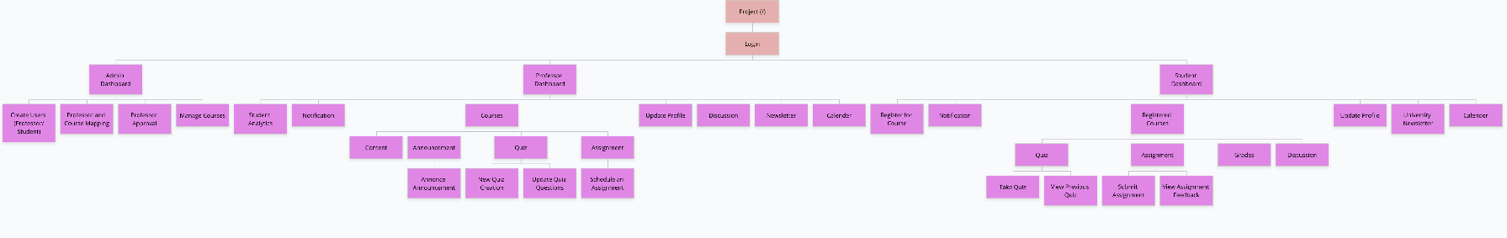

Figure 4: Site map of the web application.

# A1.4 Use cases

## User Management

Unified page for Professor Student registration (Accessible only to admins), login or deleting a specific account (Accessible only to admins). It also provides an option to reset a password through forgot password option.

**Use Case: Student and professor registration.**

1. Admin wants to create a user for professor.
2. Admin clicks on register user.
3. Admin chooses professor.
4. Fills up all the details required for professor profile.
5. Submits the new professor creation request.
6. Admin then wants to create student profile.
7. Admin clicks on register student.
8. Fills up all the profile details for student and clicks on submit.

**Use Case: User Authentication**

1. User comes on login page.
2. User enters the id and password.
   1. If the logged in user is student, he is redirected to student dashboard.
   2. If the logged in user is professor, he is redirected to professor dashboard.
   3. If the logged in user is admin, he is redirected to admin dashboard.

**Use Case: User account deletion.**

1. Admin wants to delete professor or students account as they are no longer affiliated with university.
2. Admin click on delete user button.
3. Enters email address of the user.
4. User gets deleted.

## Discussion

The logged in professor will create a topic for a discussion based on the course content and learning objectives. The discussion creation will be on the Discussion Web page which will be visible on professor dashboard only. Here we will Permit people to participate in discussions by replying to already-existing messages.

**Use Case: Discussion Creation**

1. Professor can create a discussion channel for a particular topic by clicking on a button.
2. Professor will open a chat option for the students.
3. Students on the other side can see the incoming messages from the professor.
4. Student can select the message and respond to that message and give it back to the professor.
5. Now two-way communication will be started between the professor and the students.
6. Multiple students can chat among themselves, by sending messages.
7. Students can have a text box where they can write a particular message.
8. System will have a Send button to deliver the message under that topic.
9. This is how our discussion channel will be supported to discuss doubts and important topics for the content or slides.
10. Assignments:

Use Case: Professor Assignments creation:

The professor can create an assignment with basic details for the submission based on the content and slides delivered to the students on a periodic basis. The basic workflow of the assignment creation process is as per following steps:

1. Professor will click on the create assignment button to write some details.

2. After clicking on the button, the professor will write a description of the assignment.

3. After that, the professor will upload the assignment in the form of .pdf or .doc file.

4. Professor will have an option to visible the assignment on a particular date.

5. Professor should mention a submission deadline.

6. Once the professor releases the assignment, an automatic notification will be sent to the students inside that course.

Use Case: Students Assignment View:

The student will be able to see the assignments listed on the assignment page in a list format. The basic workflow of the assignment submission process is as per following steps:

1. The student will be notified from the notification that the assignment has been created by the professor.

2. The student will go to the assignment page to see the assignment and they can see into a list format with basic details like status, submission deadline date and upload final submission into .pdf or .doc format.

3. For submission, students will click on the view assignment button, and they can see description and how to submit the assignment.

4. After that, students can click on the upload files button to upload final submission.

5. If there is no connection error or any issues not happened, then students will see the successful message saying that the files have been uploaded successfully.

6. Now students can see the status as “Completed” instead of “Incomplete”.

7. Some assignments will be visible to the students after the visible date that professor has set already on their side.

8. On the history button clicking, the window will open which will describe the submitted assignments with the description that the students have submitted for any kind of clarification to the professor.

## Quiz

### Use case: Quiz

The logged in (authenticated and authorized) student chooses a specific course from the student dashboard and comes to take a quiz for a specific course.

Or

Students come directly via the notification tab to take the quiz.

1. Student first see a list of all quizzes and grades of that course. (Finished and ongoing)
2. Student clicks on finished quiz.
3. Students see grades of the quiz, responses given and the right answers.
4. Student comes back from the previous quiz and click on the currently ongoing quiz.
5. In current quiz student has a timer to complete the quiz.
6. Quiz questions listed and student has option to select one of them.
7. After all questions are completed, student submits the quiz.
8. Students then see the grade updated for that quiz immediately.

## Student & Professor Dashboard

**Use case: Analytics Dashboard:**

1. Professor Dr. Greg Blesser wants to assess student performance and track progress.
2. Dr. Blesser navigates to the Analytics Dashboard in his professor dashboard.
3. He examines student grades, attendance, and participation to gain insights into their academic performance.

**Use case: List Courses:**

1. Student Jason Momoa wants to view his current courses and access their details.
2. Jason logs into his student dashboard and navigates to the List Courses section.
3. He sees a list of his enrolled courses, including course names, instructors, and relevant information.

**Use case: MANAGE Content by Professor:**

1. Professor Dr. Greg Blesser wants to create, view, update, and delete course content.
2. Dr. Blesser accesses the MANAGE Content feature in his professor dashboard.
3. He creates lecture slides, uploads readings, and adds multimedia resources using the content creation interface.

**Use case: View Content by Student:**

1. Student Jason Momoa wants to access and review course materials shared by professors.
2. Jason logs into his student dashboard and selects the View Content option.
3. He opens lecture slides, reads assigned readings, and watches videos provided by the professor.

**Use case: Announcement:**

1. Professor Dr. Greg Blesser wants to make important announcements to his students.
2. Dr. Blesser accesses the Announcement feature in his professor dashboard.
3. He writes announcement messages, including details, deadlines, and attachments, and sends them to the target courses.

**Use case: Profile Updates for Students:**

1. Student Jason Momoa wants to update his personal information and preferences.
2. Jason goes to his student dashboard and selects the Profile Updates option.
3. He edits his contact details and preferences and saves the changes.

## Admin Dashboard

**MANAGE Course:**

**Use case: Admin wants to create a new course in the system.**

1. Admin accesses the MANAGE Course feature in the admin dashboard.
2. Admin fills in the necessary course details (title, description, etc.).
3. Admin submits the course creation request, and the course is added to the system.

**Use case: Admin wants to view the details of an existing course.**

1. Admin selects the desired course from the course list in the admin dashboard.
2. Admin accesses the course details, including enrolled students and assigned professors.

**Use case: Admin wants to update the information of an existing course.**

1. Admin selects the desired course from the course list in the admin dashboard.
2. Admin edits the course details (title, description, etc.).
3. Admin saves the changes, and the course information is updated in the system.

**Use case: Admin wants to delete a course from the system.**

1. Admin selects the desired course from the course list in the admin dashboard.
2. Admin chooses the delete option and confirms the deletion.
3. The course is removed from the system, and all associated data (students, professors, content) is also deleted.

**Professor to Course Mapping:**

**Use case: Admin wants to assign a professor to a specific course.**

1. Admin accesses the Professor to Course Mapping feature in the admin dashboard.
2. Admin selects the desired professor and course from the available options.
3. Admin confirms the mapping, and the professor is assigned to the course.

**Professor Approval:**

**Use case:** Admin wants to add a new professor to the system.

1. Admin accesses the Professor Approval feature in the admin dashboard.
2. Admin fills in the necessary details of the new professor (name, contact information, etc.).
3. Admin submits the approval request, and the professor is added to the system.

## News

**MANAGE NEWS:**

**Use case: Admin Anya wants to create a news article to share important updates with**  **the users.**

1. Anya accesses the MANAGE News feature in the admin dashboard.
2. Anya selects the "Create News" option and fills in the article details (title, content, etc.).
3. Anya submits the news article, and it is published for users to view.

**Use case: Admin Anya wants to view the details of an existing news article.**

1. Anya selects the desired news article from the list in the admin dashboard.
2. Anya accesses the news article details, including the title, content, and publishing date.

**Use case: Admin Anya wants to update an existing news article.**

1. Anya selects the desired news article from the list in the admin dashboard.
2. Anya edits the article details (title, content, etc.).
3. Anya saves the changes, and the updated news article is published for users.

**Use case: Admin Anya wants to delete a news article from the system.**

1. Anya selects the desired news article from the list in the admin dashboard.
2. Anya chooses the delete option and confirms the deletion.
3. The news article is removed from the system and is no longer visible to users.

**Read News by Professor:**

**Use case: Professor wants to access and read the latest news articles shared by the**  **admin.**

1. The professor logs into their dashboard and navigates to the News section.
2. The professor views the list of available news articles and selects the desired article.
3. The professor reads the article's content, including any important updates or announcements.

## Notifications

**Use case: When Assignment and Quiz Gets Visible:**

1. The system automatically notifies the students when a new assignment or quiz becomes visible for a specific course.
2. Students receive a notification indicating the availability of the assignment or quiz.
3. Students can access the assignment or quiz details and begin their preparation or submission accordingly.

**Use case: Due Date Approaching:**

1. The system sends reminders to the students as the due date for an assignment or quiz approaches.
2. Students receive notifications highlighting the remaining time until the submission deadline.

**Use case: Grades and Feedback:**

1. When professors grade assignments or quizzes and provide feedback, the system notifies the students.
2. Students receive notifications regarding their grades and can access detailed feedback from the professor.

This allows students to review their performance, understand their strengths and areas for improvement, and take necessary actions.

**Use case: Content Created:**

1. Professors receive notifications when new course content, such as lecture slides, readings, or videos, is created or uploaded.
2. Professors can quickly access the newly added content and ensure it aligns with the course curriculum and requirements.

This notification ensures that professors stay updated on the course materials available to the students.

**Use case: View Notification:**

1. Students and professors can view their notification history to review past notifications.
2. The notification history displays a list of previously received notifications, categorized by type and date.

This feature allows users to revisit important information and reminders, ensuring they don't miss any crucial updates.

# A1.5 User Experience and Task Flow

## User Management [Harshil Shah]

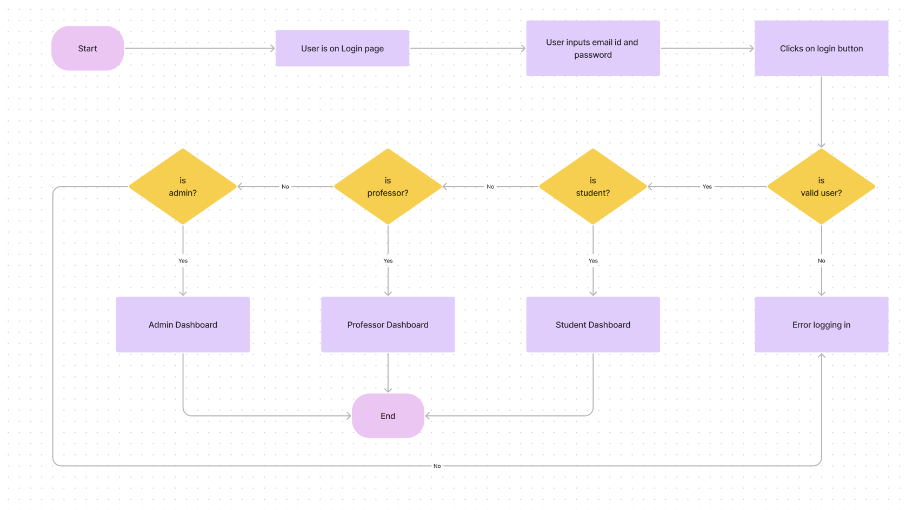

Figure 5: Task flow for login

Figure 6: Task Flow for registration

## Quiz [Raj Soni]

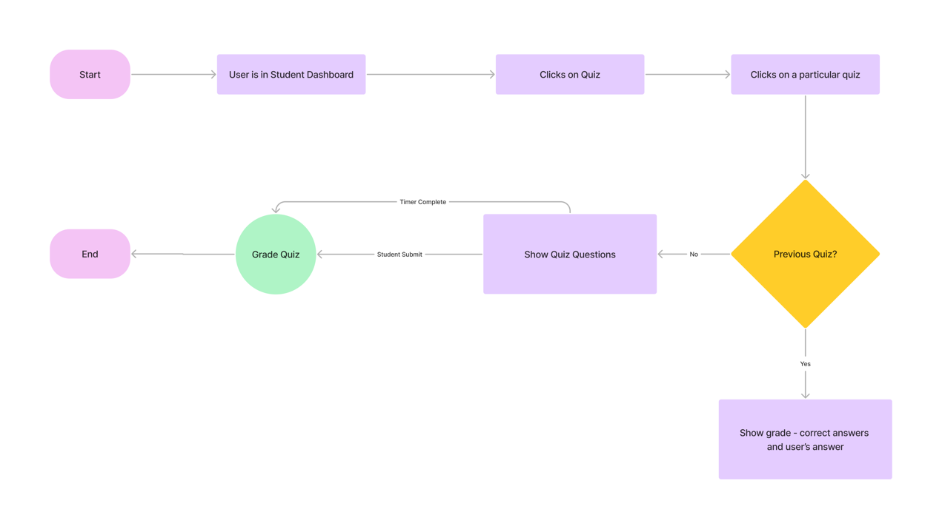

Figure : Task flow for Take Quiz

## Student & Professor Dashboard []

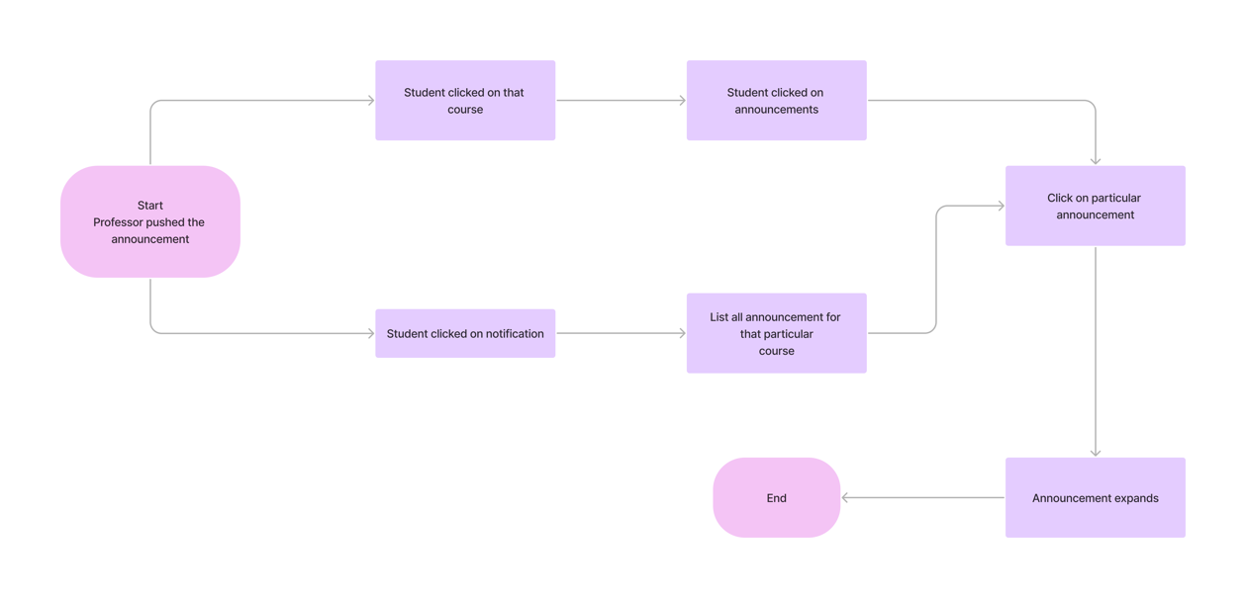

Figure : Task flow for Announcement

## Assignment [Viral Siddhapara]

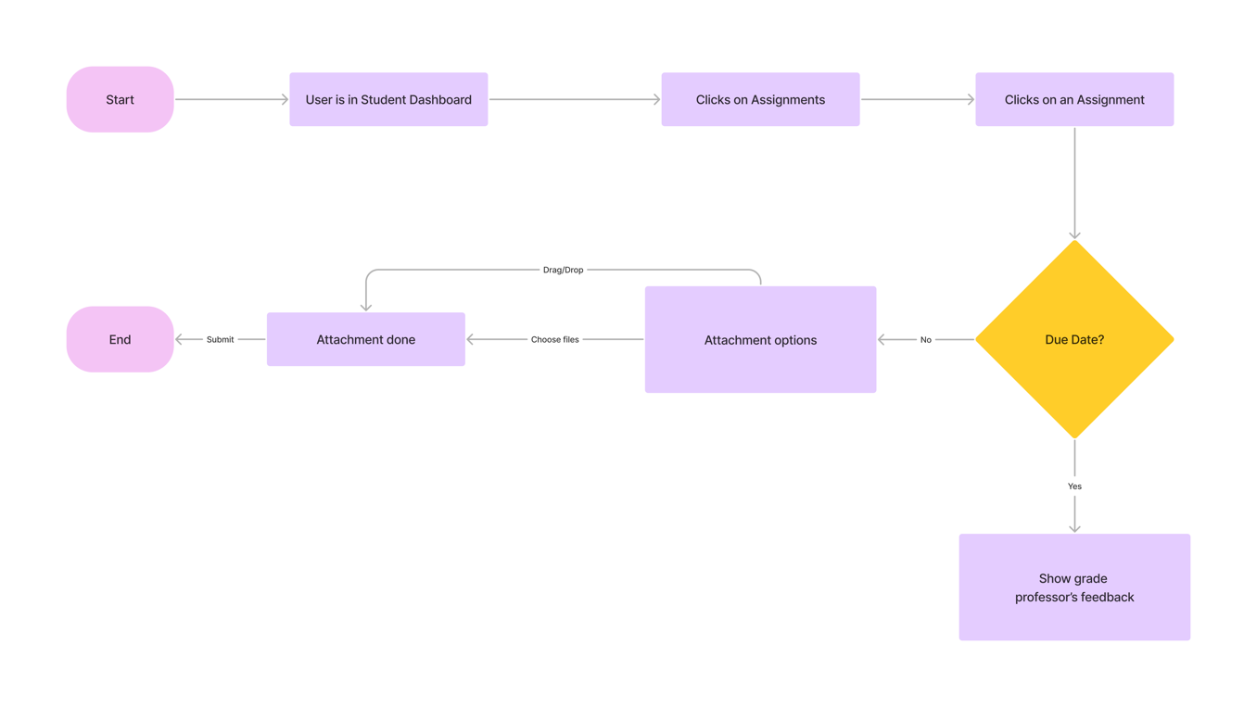

Figure : Task flow for Assignments

## Notifications [ ]

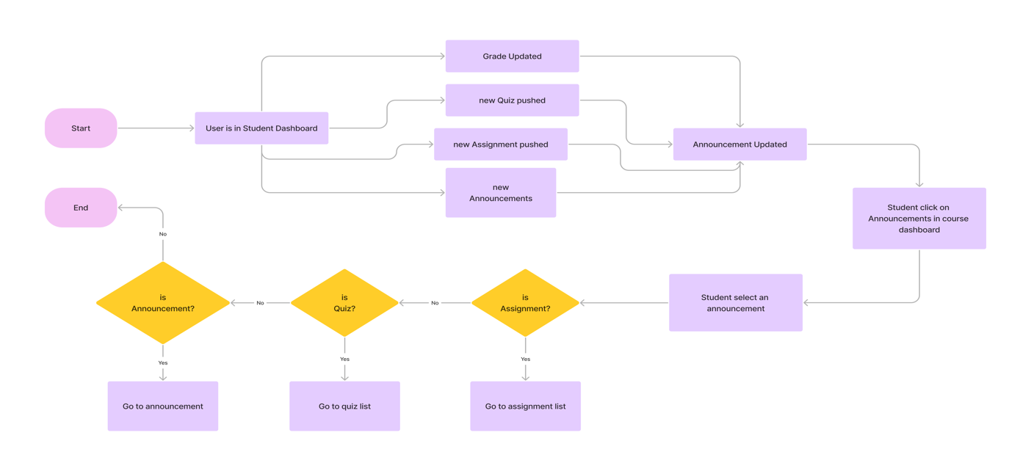

Figure : Task flow to Notifications

# A1.6 Lo-Fidelity Prototype

## Student Dashboard [Harshil Shah]:

Figure : Student Dashboard

Figure : Quiz Window

1. **Assignments [Viral Siddhapura]**

Figure : Assignment Page

Figure : Course Announcements

**References:**

[1] “Flowchart maker & online diagram software,” Diagrams.net. [Online]. Available: https://app.diagrams.net/. [Accessed: 07-Feb-2023].

[2] “Balsamiq cloud,” Balsamiq.cloud. [Online]. Available: https://balsamiq.cloud/. [Accessed: 07-Feb-2023].

[3] Uxpressia.com. [Online]. Available: https://uxpressia.com/w/Re1XL/p/w6437/p/EbiAh. [Accessed: 25-May-2023].

[4] “User Persona Template | Figma Community,” *Figma*. Available: <https://www.figma.com/community/file/1198542860250890717>. [Accessed: May 19, 2023]